Task E: SBOM and Compliance Report

Table of Contents
1. Introduction 3
2. Methodology 3
3. Findings and Analysis 4
4. Vulnerability Assessment 6
5. Compliance with NIST SSDF 7
6. Value and Practical Implications 8
7. Limitations 8
8. Conclusion 8

List of Figures
Figure 1: Building Docker File 3
Figure 2: SBOM Generation 4
Figure 3: SBOM 5
Figure 4: Vulnerability Scan 7

Introduction
Modern software systems increasingly rely on extensive third-party libraries and transitive dependencies, particularly in containerised environments. This introduces significant supply chain security risks, as vulnerabilities may exist in components that are not directly visible to developers. A Software Bill of Materials (SBOM) provides a structured inventory of all software components within an application, including direct and indirect dependencies. In this task, a vulnerable Flask-based web application was containerised using Docker and analysed using Syft to generate an SBOM in multiple formats. A vulnerability assessment was then performed using Grype to identify known Common Vulnerabilities and Exposures (CVEs). The objective was to demonstrate how SBOM generation supports compliance with the NIST Secure Software Development Framework (SSDF) while improving transparency and vulnerability management in software supply chains.

Methodology
The application environment was containerised using a Docker image based on python:3.11-slim. The Flask application and its supporting files were copied into the container and executed within an isolated runtime environment. This ensured consistency and reproducibility during analysis.
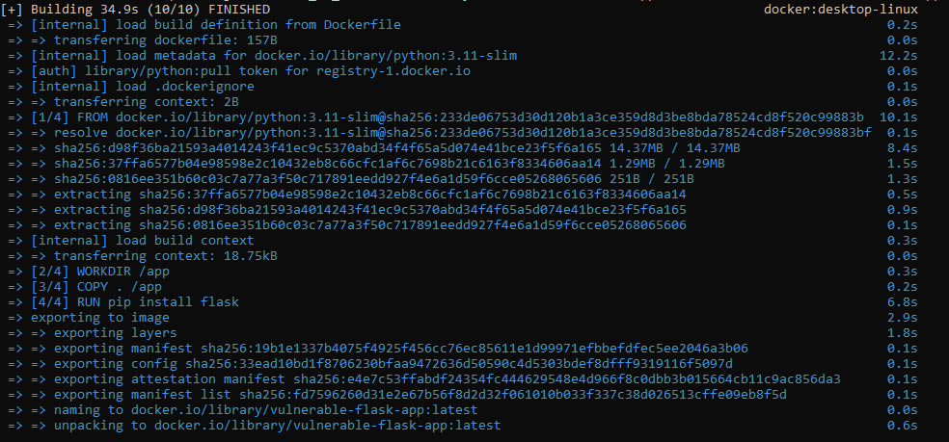
Figure 1: Building Docker File
This figure shows the successful construction of the Docker image using the command-line interface. The image was tagged as a vulnerable Flask application container, forming the basis for SBOM generation and security scanning.
Following containerisation, Syft was used to generate SBOM outputs in multiple formats:
- Table format (.txt) for human-readable inspection
- JSON format for machine parsing
- SPDX format for compliance alignment
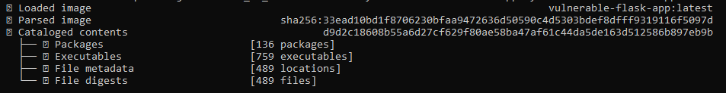
Figure 2: SBOM Generation
These figures illustrate the SBOM generation process using Syft in the command prompt, producing a structured list of installed packages within the container image.

Findings and Analysis
The SBOM analysis revealed 136 distinct software components, including operating system packages, Python dependencies, and cryptographic libraries. Key dependencies included Flask, Werkzeug, Jinja2, OpenSSL, and libc. These components form both direct and transitive dependencies, highlighting the complexity of modern application supply chains. A significant observation is that many dependencies are not explicitly installed by developers but are introduced indirectly through framework-level requirements. For example, Flask depends on Werkzeug and Jinja2, which themselves rely on additional system libraries.
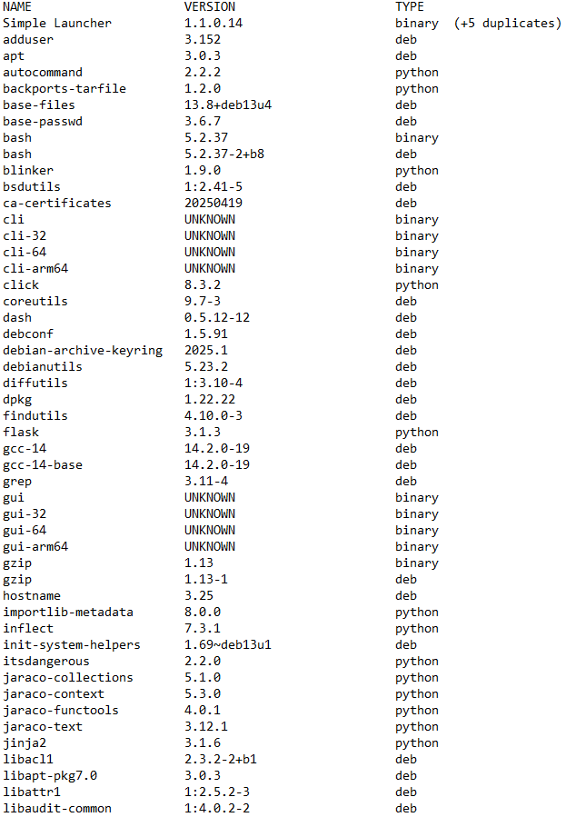
Figure 3: SBOM
This figure presents the SBOM output in tabular format, showing the full inventory of installed packages and their versions. It demonstrates the depth of dependency chains within even a simple web application.

Vulnerability Assessment
Grype was used to map SBOM components against known vulnerability databases. The scan identified 163 vulnerabilities, including:
- 1 critical vulnerability
- 33 high severity vulnerabilities
- 43 medium severity vulnerabilities
- 20 low severity vulnerabilities
Key affected components included OpenSSL, libc, and Python runtime libraries. These vulnerabilities highlight risks in cryptographic operations, memory management, and core system functions.
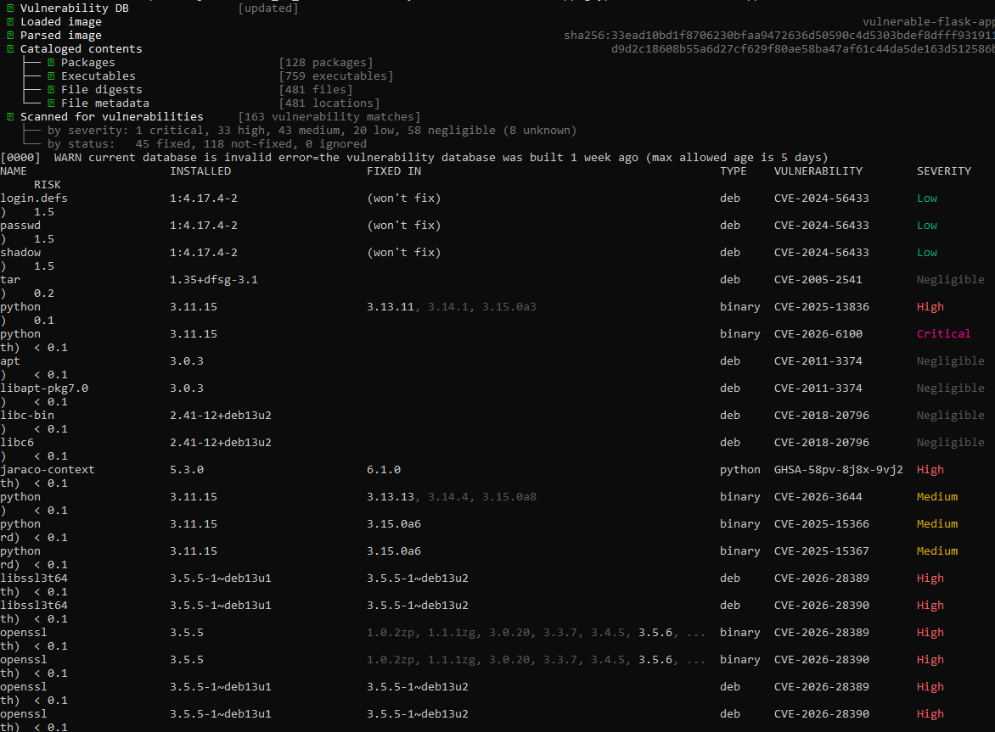
Figure 4: Vulnerability Scan
This figure shows the Grype output, including severity classification and CVE mappings. It demonstrates how SBOM data enables automated vulnerability detection across container dependencies. Several vulnerabilities were marked as “won’t fix,” indicating that upstream maintainers have chosen not to patch them due to low exploitability or backported fixes. However, such classifications still require manual risk assessment in production environments.

Compliance with NIST SSDF
The SBOM generation and vulnerability scanning process aligns with multiple practices within the NIST Secure Software Development Framework (SSDF):
- PO.1 (Define Security Requirements): SBOM provides full visibility into software composition
- PO.3 (Implement Dependency Management): Tracks third-party and transitive dependencies
- PW.4 (Secure Software Design): Enables identification of insecure components early
- PS.3 (Secure Build Process): Ensures reproducible and traceable builds
- RV.1 (Vulnerability Identification): Supports automated CVE mapping through Grype
The SBOM acts as a machine-readable artifact that enhances auditability and compliance by enabling organisations to demonstrate control over software supply chain components.

Value and Practical Implications
The integration of SBOM generation and vulnerability scanning significantly improves DevSecOps workflows. SBOMs enable continuous monitoring of software dependencies and allow security teams to rapidly identify affected components when new vulnerabilities are disclosed. This approach reduces incident response time and improves proactive security posture by shifting vulnerability detection earlier in the software development lifecycle. Additionally, SBOMs support regulatory compliance requirements and enhance transparency across software supply chains.

Limitations
Despite its advantages, SBOM-based analysis has limitations. SBOM tools such as Syft only provide visibility into known dependencies and cannot detect insecure application logic. For example, vulnerabilities such as SQL injection and insecure authentication present in the Flask application are not identified through SBOM analysis. Furthermore, SBOM accuracy depends on package metadata quality, and obfuscated or custom-built components may not be fully detected. Therefore, SBOM analysis must be complemented with static and dynamic application security testing.

Conclusion
The SBOM generated for the containerised Flask application provides comprehensive visibility into software dependencies and demonstrates the complexity of modern software supply chains. The subsequent vulnerability analysis using Grype identified multiple security issues across system and application libraries. This workflow aligns with NIST SSDF principles by ensuring transparency, traceability, and vulnerability management within the software lifecycle. However, SBOM analysis alone is insufficient for complete security assurance, as it does not address application-level vulnerabilities. Therefore, SBOM-based supply chain security should be integrated with secure coding practices and runtime security monitoring to achieve robust software assurance.

